|  |  |
| --- | --- |
| **Soal Praktikum**  *Practicum Case* |  |
| ISYS6028  Database Systems |
| **Teknik Informatika**  *Computer Science* | O221-ISYS6028-DW01-08 |
| **Periode Berlaku Mulai** Semester Ganjil 2017/2018  ***Valid on*** *Odd Semester Year* 2017/2018 | **Revisi 00**  *Revision 00* |

**Learning Outcomes**

* Apply database language and SQL Programming language
* Evaluate database processing and security Mechanism

## Topic

* Session 08 **-** SQL – Data Definition (2)

## Sub Topics

* **Create and Update View**
* **Dropping Views**
* Access control : GRANT and REVOKE command

**Tabel Relasional**

*Relational Table*

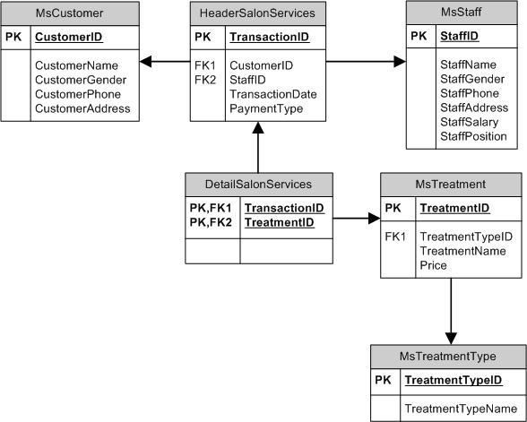

**Sintaks**

*Syntax*

**Create view**

Create view **view_name**

[ ( column , .....) ]

As subquery

[ with check option]

**Drop View**

Drop view [**view_name**]

## Soal

*Case*

## Create a view named ‘ViewBonus’ to display BinusId (obtained from CustomerID by replacing the first 2 characters with ‘BN ’), and CustomerName for every customer whose name is more than 10 characters.

**(create view**, **stuff**, **len)**

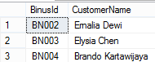

1. Create a view named ‘ViewCustomerData’ to display Name (obtained from customer’s name from the first character until a character before space), Address (obtained from CustomerAddress), and Phone (obtained from CustomerPhone) for every customer whose name contains space.

**(create view**, **substring**, **charindex)**

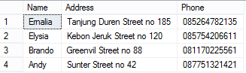

1. Create a view named ‘ViewTreatment’ to display TreatmentName, TreatmentTypeName, Price (obtained from Price by adding ‘Rp. ’ in front of Price) for every treatment which type is ‘Hair Treatment’ and price is between 450000 and 800000.

**(create view**, **cast**, **between)**

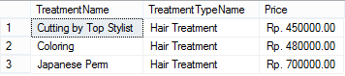

1. Create a view named ‘ViewTransaction’ to display StaffName, CustomerName, TransactionDate (obtained from TransactionDate in ‘dd mon yyyy’ format), and PaymentType for every transaction which the transaction is between 21st and 25th day and was paid by ‘Credit’.

**(create view**, **convert**, **day**, **between)**

**C:\Users\AdityaMili\Desktop\BANK SOAL\Bank Case Making\03 -\new\4.png**

1. Create a view named ‘ViewBonusCustomer’ to display BonusId (obtained from CustomerId by replacing ‘CU’ with ‘BN’), Name (Obtained from CustomerName by taking the next character after space until the last character in lower case format), Day (obtained from the day when the transaction happened), and TransactionDate (obtained from TransactionDate in ‘mm/dd/yy’ format) for every transaction which customer’s name contains space and staff’s last name contains ‘a’ character.

**(create view**, **replace**, **lower**, **substring**, **charindex**, **len**, **datename**, **weekday**, **convert**, **like)**

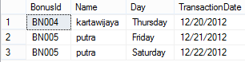

1. Create a view named ‘ViewTransactionByLivia’ to display TransactionId, Date (obtained from TransactionDate in ‘Mon dd, yyyy’ format), and TreatmentName for every transaction which occurred on the 21st day and handled by staff whose name is ‘Livia Ashianti’.

**(create view, convert, day, like)**

**C:\Users\AdityaMili\Desktop\BANK SOAL\Bank Case Making\03 -\new\6.png**

1. Change the view named ‘ViewCustomerData’ to ID (obtained from the last 3 digit characters of CustomerID), Name (obtained from CustomerName), Address (obtained from CustomerAddress), and Phone (obtained from CustomerPhone) for every customer whose name contains space.

**(alter view, right, charindex)**

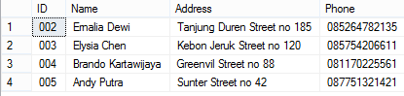

1. Create a view named ‘ViewCustomer’ to display CustomerId, CustomerName, CustomerGender from MsCustomer, then add the data to ViewCustomer with the following specifications:

|  |  |  |
| --- | --- | --- |
| **CustomerID** | **CustomerName** | **CustomerGender** |
| CU006 | Cristian | Male |

(**create** **view**, **insert**)

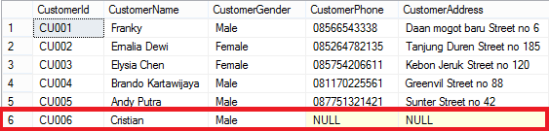

1. Delete data in view ‘ViewCustomerData’ that has ID ‘005’. Then display all data from **ViewCustomerData**.

**(delete)**

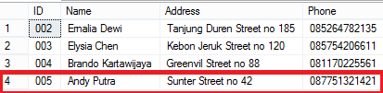

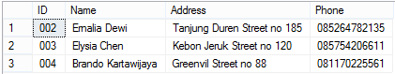

1. Delete the view named *‘*ViewCustomerData’.

(**drop view**)